REPLACE AND MODERNIZE LEGACY VPN
ARCHITECTURE WITH A CLOUD - NATIVE
ZSCALER ZERO TRUST SOLUTION TO REDUCE ATTACK SURFACE AND LATERAL MOVEMENT

TEAM ID: SWTID-2026-8743

GROUP DETAILS:

S.NO | NAME | COLLEGE  NAME | CONTACT
1. | VAISHNAVI N(Team  Lead) | Tiruppur Kumaran  College For  Women | s99967075@gmail.com
2. | DHARANI C(Team Member) | Tiruppur Kumaran  College For  Women | dhrndeepika@gmail.com
3. | THARANI G(Team Member) | Tiruppur Kumaran  College For  Women | dharaniganesan357@gmail.com
4. | THEJASHVINI U(Team Member) | Tiruppur Kumaran  College For  Women | thejasanjith@gmail.com

PROJECT DETAILS:
TITLE: REPLACE AND MODERNIZE LEGACY VPN ARCHITECTURE WITH A CLOUD - NATIVE ZSCALER ZERO TRUST SOLUTION TO REDUCE ATTACK SURFACE AND LATERAL MOVEMENT

INTRODUCTION:
Traditional Virtual Private Network (VPN) architectures were designed to provide secure remote access to organizational networks. However, as cyber threats have evolved, these legacy systems have become increasingly vulnerable. VPNs follow a perimeter-based security model that assumes users inside the network are trustworthy. If attackers gain access through compromised credentials or vulnerabilities, they can move laterally across systems, increasing the risk of major data breaches.
To overcome these limitations, organizations are adopting the Zero Trust security model, which operates on the principle of “never trust, always verify.” This approach continuously validates users, devices, and access requests before granting permission to organizational resources. A leading platform enabling this approach is Zscaler, which provides cloud-native security through the Zscaler Zero Trust Exchange platform.
By replacing legacy VPN infrastructure with a Zscaler-based Zero Trust solution, organizations can reduce their attack surface, prevent lateral movement within networks, and improve overall security while supporting modern cloud and remote work environments.

ABSTRACT:
Traditional Virtual Private Network (VPN) architectures have long been used to provide secure remote access to enterprise networks. However, with the rapid growth of cloud computing, remote work, and advanced cyber threats, legacy VPN systems have become increasingly vulnerable to security risks such as unauthorized access, expanded attack surfaces, and lateral movement within networks. These challenges highlight the need for a more modern and secure approach to network access.
This study focuses on replacing legacy VPN infrastructure with a cloud-native Zero Trust architecture using solutions from Zscaler, particularly the Zscaler Zero Trust Exchange platform. The Zero Trust model follows the principle of “never trust, always verify,” where every user, device, and application request is continuously authenticated and authorized before access is granted. Unlike traditional VPNs that provide broad network access, Zero Trust enables secure, identity-based access directly to specific applications without exposing the internal network.
By adopting this modern architecture, organizations can significantly reduce their attack surface, limit lateral movement, and strengthen overall security posture. In addition, the cloud-native approach improves scalability, performance, and user experience while supporting modern digital transformation and remote workforce requirements. This transition represents a critical step toward building a more resilient and secure enterprise network environment.

USE CASE SCENARIO:

Secure Remote Workforce Access
Employees working from home traditionally connect through VPN to access internal applications, which exposes the internal network. Using Zscaler and Zscaler Zero Trust Exchange, users are authenticated and connected directly to specific applications instead of the entire network. This reduces the attack surface and improves security for remote workers.

Third-Party Vendor Access Control
External vendors often require temporary access to enterprise systems. With legacy VPNs, vendors may gain broader network access than necessary. A Zero Trust solution allows organizations to grant application-level access only, ensuring vendors can access only the resources required for their tasks.

Protection Against Lateral Movement
If an attacker compromises a user account in a VPN environment, they can move laterally across systems inside the network. With a Zero Trust architecture, each request is verified continuously, and access is limited to specific applications, preventing attackers from moving across the network.

Secure Access to Cloud Applications
As organizations migrate workloads to cloud platforms, traditional VPNs become inefficient. A cloud-native Zero Trust model enables users to securely access SaaS and cloud applications without routing traffic through corporate data centers, improving performance and security.

Secure Access for Branch Offices
Branch offices typically rely on VPN tunnels to connect to the main corporate network. By adopting Zero Trust through Zscaler Zero Trust Exchange, branch users can securely access applications directly from the cloud, reducing dependency on centralized VPN infrastructure and improving scalability.

STAGE-1
Title: owasp to 10

OVERVIEW
The OWASP (Open Worldwide Application Security Project) Top 10 is a widely recognized standard that identifies the most critical security risks to web applications. It provides developers, security professionals, and organizations with awareness of common vulnerabilities that attackers frequently exploit. The list is updated periodically based on real-world data and security research.
The OWASP Top 10 helps organizations improve application security by highlighting major risk areas such as broken access control, cryptographic failures, injection attacks, and security misconfigurations. By understanding and addressing these vulnerabilities, organizations can reduce security risks, protect sensitive data, and build more secure software systems.
Overall, the OWASP Top 10 acts as a guideline for secure coding practices, risk management, and security testing in modern web application development.

VULNERABILITY:

S.NO | VULNERABILITY NAME | CWE/CVE NO
1. | Absolute Path Traversal | CWE 36
2. | Password in Configuration File | CWE-260
3. | Key Management Errors | CWE-320
4. | Unimplemented or Unsupported Feature in UI | CWE-447
5. | Improper Neutralization of Equivalent Special  Elements | CWE-76
6. | Improper Privilege Management | CWE-269
7. | Improper Authentication | CWE-287
8. | Uncontrolled Search Path Element | CWE-427
9. | Information Loss or Omission | CWE-221
10. | Divide By Zero | CWE-369

REPORT:
- VULNERABILITY NAME: Absolute Path Traversal
CWE/CVE NUMBER: CWE 36

OWASP CATEGORY: A01:2025 Broken Access Control

DESCRIPTION: Absolute Path Traversal is a vulnerability where an attacker uses a full file system path (e.g., /etc/passwd) to access files outside the intended directory. This can allow unauthorized access to sensitive system files on the server.

BUSINESS IMPACT:

  - Unauthorized Data Access: Attackers may access sensitive files such as configuration files, credentials, or customer data, leading to data breaches.
  - System Compromise: Exposure of critical system files can help attackers gain deeper access to servers and potentially take control of the application.
  - Financial and Reputation Loss: Security breaches can result in financial penalties, legal consequences, and damage to the organization’s reputation.
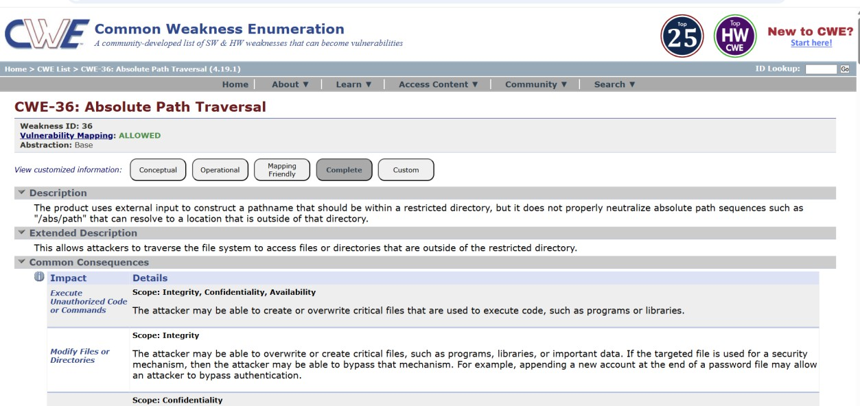

- VULNERABILITY NAME: Password in Configuration File
CWE/CVE NUMBER: CWE-260

OWASP CATEGORY: A02:2025 Security Misconfiguration

DESCRIPTION: This vulnerability occurs when passwords or sensitive credentials are stored in plain text within configuration files. If these files are accessed by unauthorized users, attackers can easily obtain the credentials.
BUSINESS IMPACT: Attackers may gain unauthorized access to systems or databases, leading to data breaches, financial loss, and damage to the organization’s reputation.
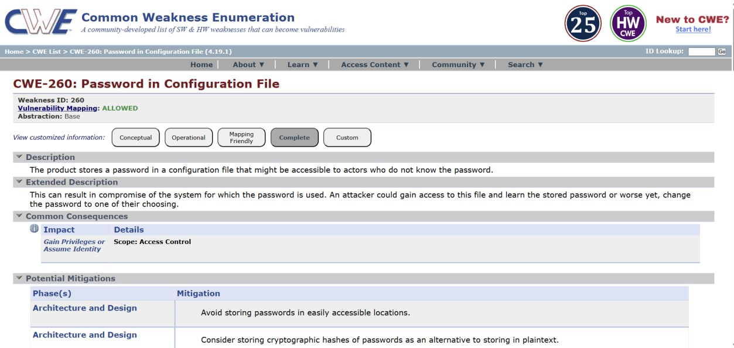

- VULNERABILITY NAME: Key Management Errors

CWE/CVE NUMBER: CWE-320

OWASP CATEGORY: A04:2025 Cryptographic Failures

DESCRIPTION: Key management errors occur when encryption keys, API keys, or cryptographic secrets are improperly generated, stored, or rotated. Weak key management can allow attackers to bypass encryption or authentication protections.
BUSINESS IMPACT: Compromised keys can lead to unauthorized data access, loss of data confidentiality, regulatory penalties, and severe damage to organizational trust and reputation.
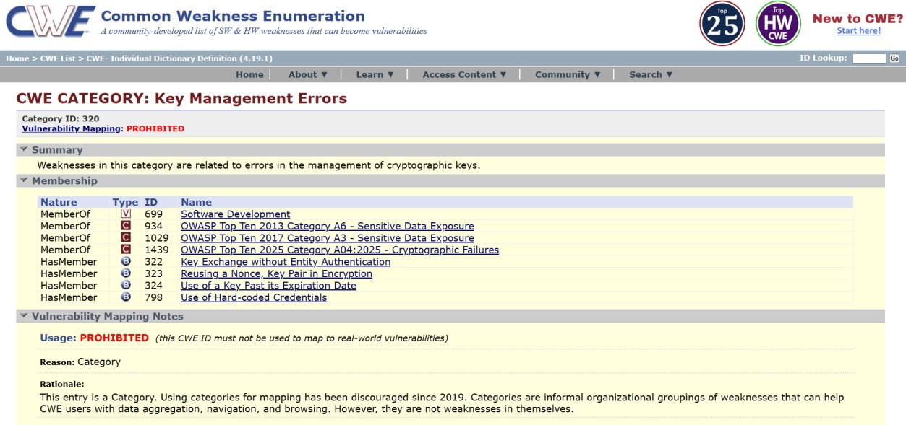

- VULNERABILITY NAME: Unimplemented or Unsupported Feature in UI

CWE/CVE NUMBER:CWE-447

OWASP CATEGORY: A03:2025 Software Supply Chain Failures

DESCRIPTION: This vulnerability arises when user interface (UI) elements suggest functionality that is either not implemented or not supported. Attackers can exploit these misleading features to trigger unexpected behavior or bypass security controls.
BUSINESS IMPACT: Exploiting such features can lead to unauthorized access, data manipulation, or system misuse, resulting in operational disruptions, potential data breaches, and reputational damage for the organization.
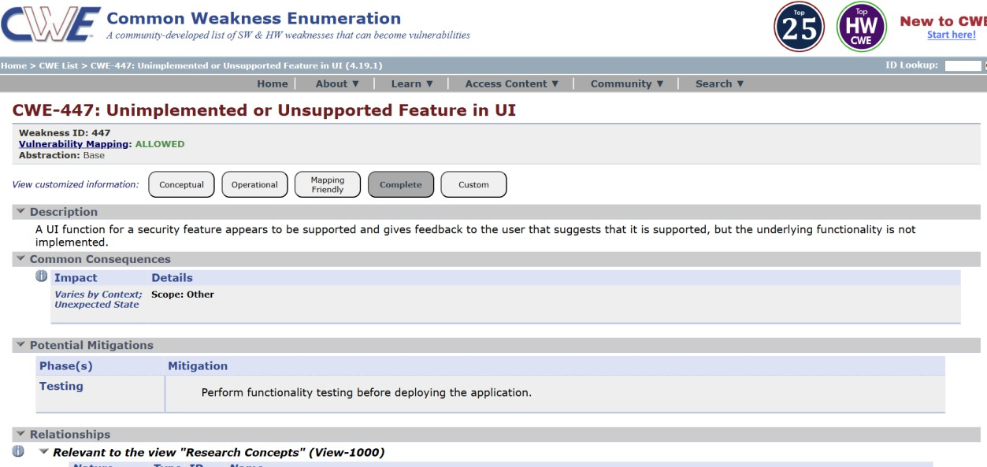

- VULNERABILITY NAME: Improper Neutralization of Equivalent Special Elements

CWE/CVE NUMBER: CWE-76

OWASP CATEGORY: A05:2025 Injection

DESCRIPTION: This vulnerability occurs when user input containing special characters, encoding variations, or equivalent elements (like HTML entities or Unicode characters) is not properly validated or sanitized. Attackers can exploit it to inject malicious content, bypass input filters, or manipulate system behavior.
BUSINESS IMPACT: Exploitation can lead to cross-site scripting (XSS), data corruption, unauthorized access, or security control bypass, resulting in data breaches, regulatory penalties, and loss of customer trust.
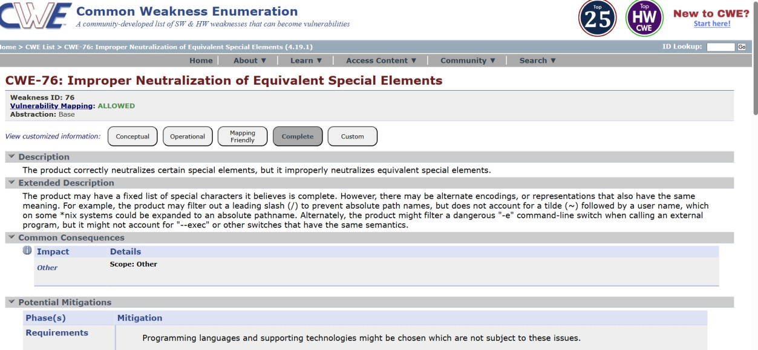

- VULNERABILITY NAME: Improper Privilege Management

CWE/CVE NUMBER: CWE-269

OWASP CATEGORY: A06:2025 Insecure Design

DESCRIPTION: This vulnerability occurs when users or processes are granted more permissions than necessary, or access controls are not correctly enforced. Attackers can exploit this to perform unauthorized actions or access sensitive resources.
BUSINESS IMPACT: Exploitation can lead to data theft, unauthorized system changes, financial loss, regulatory violations, and significant reputational damage.

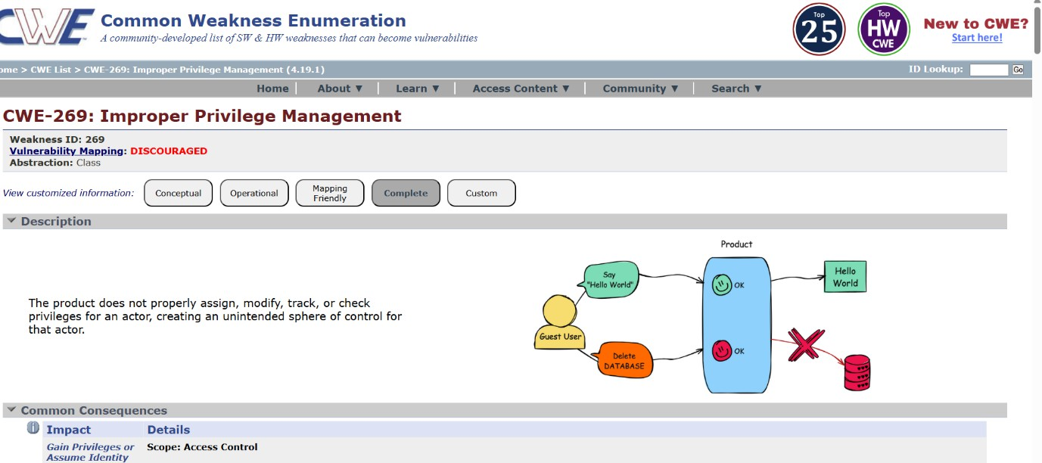

- VULNERABILITY NAME: Improper Authentication

CWE/CVE NUMBER: CWE-287

OWASP CATEGORY: A07:2025 Authentication Failures

DESCRIPTION: This vulnerability occurs when an application fails to correctly verify a user’s identity, allowing attackers to bypass login mechanisms, impersonate users, or gain unauthorized access.
BUSINESS IMPACT: Exploitation can result in data breaches, unauthorized transactions, account compromise, regulatory penalties, financial loss, and damage to the organization’s reputation.
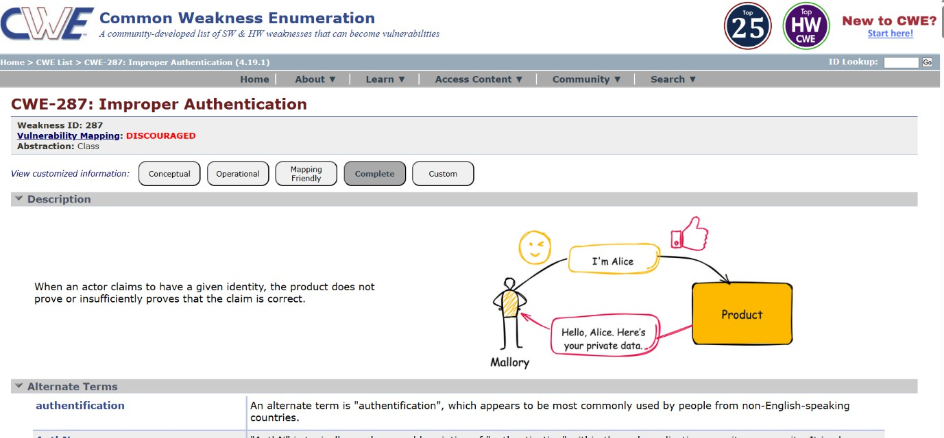

- VULNERABILITY NAME: Uncontrolled Search Path Element

CWE/CVE NUMBER: CWE-427

OWASP CATEGORY: A08:2025 Software or Data Integrity Failures

DESCRIPTION: This vulnerability occurs when an application or system uses insecure or unvalidated paths to locate executable files or libraries. Attackers can manipulate these paths to execute malicious code.
BUSINESS IMPACT: Exploitation can lead to remote code execution, system compromise, data breaches, service disruption, financial loss, and reputational damage.
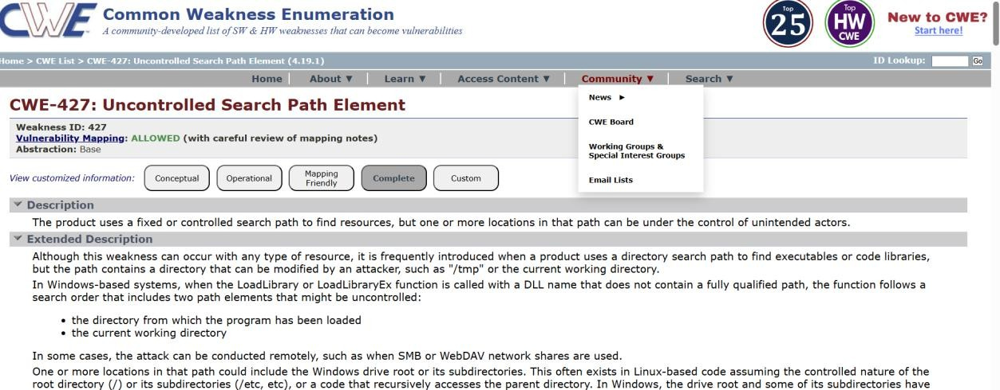

- VULNERABILITY NAME: Information Loss or Omission

CWE/CVE NUMBER: CWE-221

OWASP CATEGORY: A09:2025 Security Logging & Alerting Failures

DESCRIPTION: This vulnerability occurs when an application fails to capture, log, or transmit critical information accurately, leading to incomplete or missing data.
BUSINESS IMPACT: It can result in poor decision-making, operational failures, regulatory non-compliance, financial loss, and damage to organizational credibility and trust.
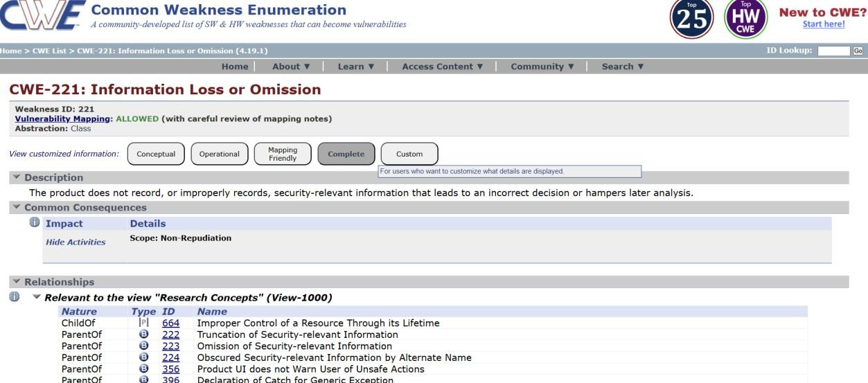

- VULNERABILITY NAME: Divide By Zero

CWE/CVE NUMBER: CWE-369

OWASP CATEGORY: A10:2025 Mishandling of Exceptional Conditions

DESCRIPTION: This vulnerability occurs when an application performs a division operation with a denominator of zero, causing runtime errors, crashes, or unexpected behavior.
BUSINESS IMPACT: Exploitation or occurrence can lead to system downtime, application crashes, disrupted services, loss of data integrity, and potential financial and reputational damage.
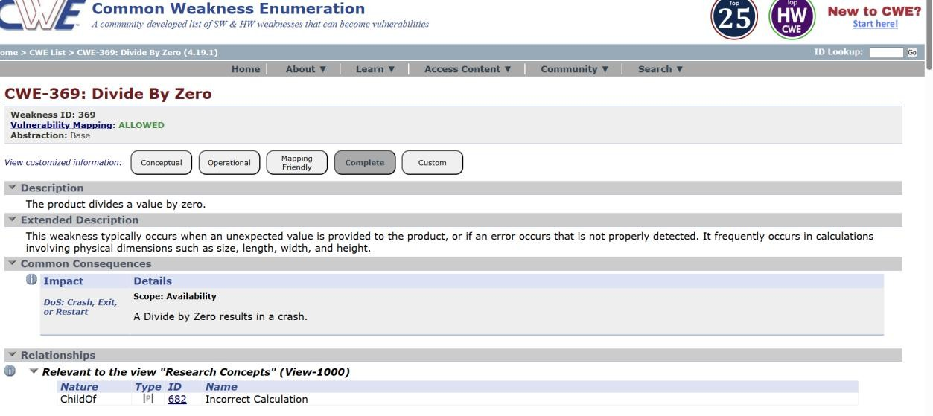

STAGE-2
TITLE: Nessus scan

OVERVIEW:

Nessus is a widely used vulnerability scanning tool developed by Tenable that helps organizations identify security weaknesses in their networks, systems, and applications. It performs automated scans to detect misconfigurations, missing patches, outdated software, and known vulnerabilities that could be exploited by attackers. Nessus supports multiple platforms, including Windows, Linux, and network devices, making it a versatile tool for enterprise security assessments.
The scanner works by using a regularly updated vulnerability database and a variety of plugins to check for issues such as open ports, weak passwords, insecure services, and compliance gaps. Results are presented in detailed reports with risk ratings, allowing security teams to prioritize remediation efforts effectively. Nessus can perform both credentialed scans, which access systems with proper credentials for deeper assessment, and non-credentialed scans, which simulate external attacks without system access.
By using Nessus, organizations can proactively detect vulnerabilities before attackers exploit them, improve compliance with security standards, and strengthen their overall cybersecurity posture. Its combination of automation, accuracy, and comprehensive reporting makes it a cornerstone tool in modern vulnerability management programs.

S.No | Vulnerability name | Severity | Plugins
1. | General | INFO | 12053
2. | Port Scanners | INFO | 11219
3. | Service Detection | INFO | 22964
4. | Web Servers | INFO | 24260
5. | Web Servers | INFO | 10107

REPORT:

- VULNERABILITY NAME: General

SEVERITY: INFO

PLUGINS: 12053

DESCRIPTION: This informational finding indicates a general observation identified by the Nessus plugin 12053. It is not classified as a critical or high-risk vulnerability but may provide useful details about the system configuration, software versions, or network setup that could be relevant for further analysis.
SOLUTION: No immediate action is required for informational severity items. Review the details provided by the plugin to ensure configurations are aligned with best practices and organizational security policies. Use this information to support ongoing monitoring and risk assessment.
BUSINESS IMPACT: Since this is an informational finding, it poses minimal or no direct risk to the organization. However, ignoring informational alerts may result in missed insights about system configurations or potential areas that could be exploited if combined with other vulnerabilities, so regular review is recommended.

- VULNERABILITY NAME: Port Scanners

SEVERITY: INFO

PLUGINS: 11219

DESCRIPTION: This informational finding indicates that a port scanning activity has been detected or that the system has open ports visible to scanning. It does not represent an active vulnerability but serves as a notification that the host could be discovered or enumerated by attackers performing reconnaissance.
SOLUTION: No immediate remediation is required for informational severity. Organizations should ensure proper firewall rules, network segmentation, and intrusion detection/prevention systems (IDS/IPS) are in place to monitor or limit unauthorized scanning activity

BUSINESS IMPACT: While informational in nature, exposure to port scanning can provide attackers with knowledge about open ports and services, which may be used in planning attacks. Regular monitoring and network hardening reduce potential reconnaissance risks and strengthen overall security posture

- VULNERABILITY NAME: Service Detection

SEVERITY: INFO

PLUGINS: 22964

DESCRIPTION: This informational finding indicates that Nessus was able to identify services running on the target system, such as web servers, databases, or other network services. It is not a direct vulnerability but provides insight into the system’s configuration and exposed services.
SOLUTION: No immediate action is required. Organizations should review the identified services to ensure only necessary services are running and that they are properly secured and updated. Unnecessary services should be disabled or restricted to reduce potential attack vectors.
BUSINESS IMPACT: While informational, knowledge of active services can help attackers plan targeted attacks. Reviewing and hardening exposed services reduces the risk of exploitation, protects sensitive data, and strengthens overall security posture.

- VULNERABILITY NAME: Web Servers

SEVERITY: INFO

PLUGINS: 24260

DESCRIPTION: This informational finding indicates that Nessus has detected one or more web servers running on the target system. It does not represent a direct vulnerability but provides visibility into active web services and their configurations.
SOLUTION: No immediate remediation is required. Organizations should review the web servers to ensure they are updated with the latest security patches, unnecessary services are

disabled, and proper hardening measures (like secure headers, TLS configurations, and access controls) are in place.
BUSINESS IMPACT: While this is informational, exposed web servers may attract attackers performing reconnaissance. Properly securing and monitoring these services helps prevent unauthorized access, data leakage, or potential exploitation, reducing overall risk to the organization.

- VULNERABILITY NAME: Web Servers

SEVERITY: INFO

PLUGINS: 10107

DESCRIPTION: This informational finding indicates that Nessus has identified one or more web servers running on the target system. It does not indicate a direct vulnerability but highlights the presence of web services that could be potential targets if not properly secured.
SOLUTION: No immediate action is required. Organizations should ensure the web servers are updated with the latest security patches, unnecessary services are disabled, and security best practices—such as strong access controls, secure configurations, and TLS/HTTPS enforcement—are implemented.
BUSINESS IMPACT: Although informational, the presence of web servers exposes systems to reconnaissance and potential exploitation. Proper hardening, monitoring, and patch management reduce the risk of attacks, data breaches, and operational disruption.

STAGE-3
TITLE: REPLACE AND MODERNIZE LEGACY VPN ARCHITECTURE WITH A CLOUD - NATIVE ZSCALER ZERO TRUST SOLUTION TO REDUCE ATTACK SURFACE AND LATERAL MOVEMENT

OVERVIEW:
Legacy VPN architectures provide remote access but rely on a perimeter-based security model, making them vulnerable to unauthorized access and lateral movement within networks. Modern organizations are moving to a cloud-native Zero Trust approach using Zscaler and its Zscaler Zero Trust Exchange platform, which continuously verifies users, devices, and applications before granting access.
Replacing VPNs with this solution reduces the attack surface, prevents lateral movement, and improves security, scalability, and user experience for remote and cloud-based environments.
- IDENTITY: Verifies the user’s identity before granting access, ensuring only authorized users can reach applications.
- DEVICE POSTURE: Assesses the security status of devices (e.g., OS updates, antivirus, encryption) to determine if they meet access requirements.
- APPLICATION RISK: Evaluates the sensitivity and risk level of applications to enforce appropriate access controls and protection measures.
- CONTEXT-AWARE ACCESS: Grants or restricts access based on contextual factors like location, device, time, and user behavior for dynamic security enforcement.

CONCLUSION:
STAGE:1
The Stage 1 assessment has identified several critical vulnerabilities across the system, ranging from input validation and authentication issues to improper configuration and key management weaknesses. These findings indicate that the current system has potential exposure points that could be exploited to gain unauthorized access, manipulate data, or disrupt operations. While some vulnerabilities stem from coding errors, others arise from insecure handling of sensitive information and insufficient access controls. Addressing these issues at an early stage is crucial to strengthen the system’s security posture, prevent potential breaches, and ensure compliance with best practices. Moving forward, a prioritized remediation plan focusing on high-risk vulnerabilities will be essential to enhance the overall reliability and trustworthiness of the application.

STAGE:2
The Stage 2 Nessus assessment primarily identified informational-level findings, including general system information, port scanning results, service detection, and web server details. These findings indicate that while no critical or high-severity vulnerabilities were detected at this stage, the scan provides valuable insight into the system’s exposed services and potential attack surface. Understanding these informational points is essential for monitoring, hardening services, and planning future security assessments. Overall, the system currently does not exhibit immediate high-risk vulnerabilities, but continuous monitoring and further in-depth testing are recommended to maintain a strong security posture.

STAGE:3
The assessment in Stage 3 highlights the need to replace the legacy VPN architecture with a cloud-native Zscaler Zero Trust solution. Transitioning to a Zero Trust model will significantly reduce the attack surface by eliminating implicit trust, restricting lateral movement, and enforcing strict access controls at the application level. This approach modernizes the security framework, enhances visibility into user and device activity, and strengthens protection against advanced threats. Implementing this solution lays the foundation for a more resilient, scalable, and secure network, ensuring that only authorized users and devices can access critical resources while minimizing exposure to potential breaches.

FUTURE SCOPE:
STAGE:1
- Secure Coding Practices: Implementing strict input validation, proper error handling, and secure authentication mechanisms to prevent exploits like absolute path traversal, divide-by-zero errors, and improper privilege management.
- Configuration and Key Management: Ensuring sensitive information, such as passwords and encryption keys, is securely stored and managed to reduce the risk of unauthorized access.
- Access Control Enhancements: Applying role-based access controls, privilege auditing, and continuous monitoring to prevent unauthorized actions and enforce least-privilege principles.
- Regular Security Testing: Conducting periodic vulnerability assessments, penetration testing, and code reviews to proactively identify and remediate emerging risks.
- User Awareness and Training: Educating developers and administrators about security best practices to prevent common implementation mistakes and enhance overall security hygiene.

STAGE:2
- Service and Port Hardening: Review all detected open ports and running services to minimize unnecessary exposure, reducing the potential attack surface.
- Continuous Monitoring: Implement regular vulnerability scanning and real-time monitoring to detect new or emerging threats before they can be exploited.
- Web Server and Application Security: Analyze web server configurations and services for optimization and security best practices to prevent misconfigurations that could be leveraged by attackers.
- Integration with Security Tools: Leverage the scan data to integrate with SIEM or endpoint protection tools, enabling proactive threat detection and automated response.
- Planning for Deeper Assessments: Use informational data as a baseline for future in-depth assessments, including authenticated scans and penetration testing, to uncover higher-severity vulnerabilities.

STAGE:3
- Zero Trust Expansion: Gradually extend Zero Trust policies to all applications, cloud workloads, and remote users to minimize implicit trust across the network.
- Advanced Threat Protection: Integrate real-time threat intelligence and analytics to detect and block sophisticated attacks before they impact critical systems.
- User and Device Analytics: Implement continuous monitoring of user behavior and device posture to dynamically enforce access policies and identify anomalies.
- Automation and Orchestration: Leverage automated policy enforcement, logging, and reporting to streamline security operations and reduce manual intervention.
- Scalability and Future-Proofing: Ensure that the architecture can adapt to organizational growth, cloud adoption, and emerging technologies without compromising security.

TOPICS EXPLORED: owasp top 10, scanning, vulnerability, awareness, identity

TOOLS EXPLORED: Zscaler, Nessus

WEBSITE: https://demo.testfire.net/

